## **Cooky**

1. 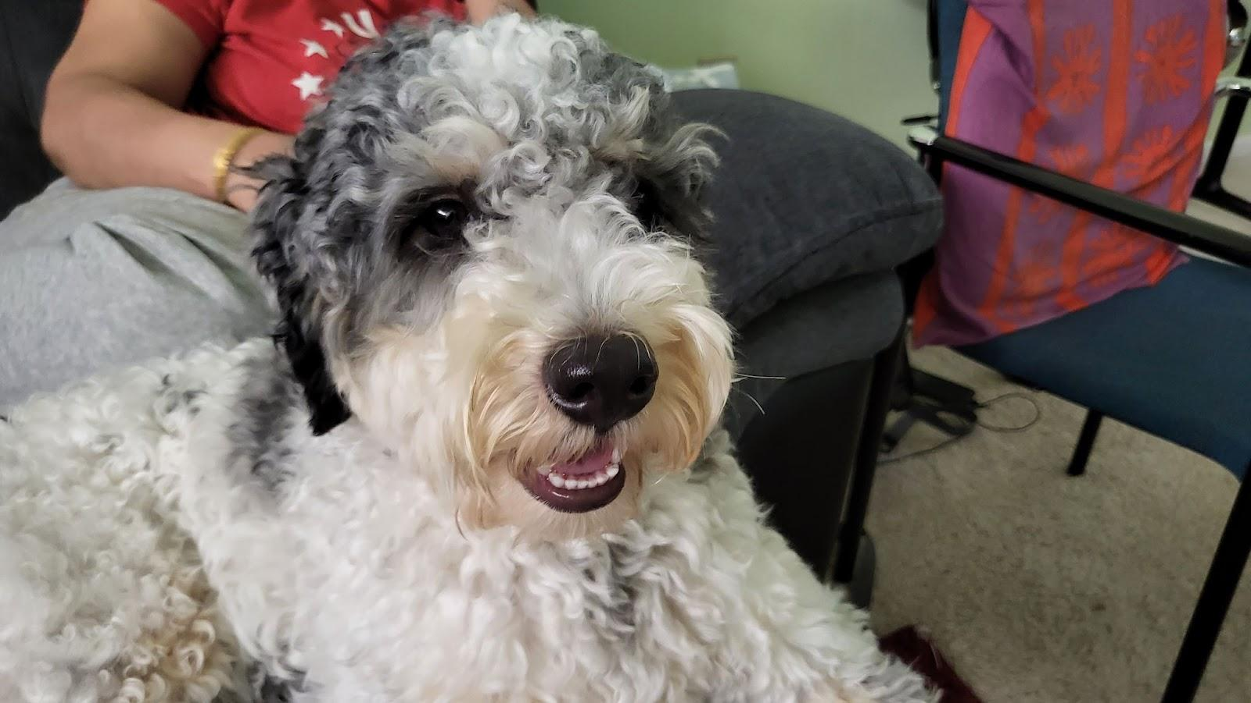
2. cookysmiley.jpg
3. White and gray Bernedoodle sitting on a couch and smiling.
4. Cooky is an 11 month old Bernedoodle. He likes to play, run around, go on walks, eat snacks and treats (not his own dog food), get pets and belly rubs, and cuddle. You can usually find him playing with his toys in the living room, chilling in the office room with my dad, or cooling off in the garage.
5. He’s still a baby, but he can get super hyper. Whenever someone rings the doorbell, Cooky gets really excited, barking and dashing towards the front door. He also jumps really high when he’s hyper and wags his tail like crazy. Overall, though, he likes to chill and cuddle just as much as he likes to play.
6. **Photo Gallery**
7. cookytreat.jpg
8. Cooky eating one of his favorite treats while lying on the ground
9. cookytired.jpg
10. Cooky tired laying on the ground
11. cookycone.jpg
12. Cooky with long hair sitting with a dog cone on his head
13. cookyzoom.jpg
14. Zoomed in Cooky, but while I was taking the picture he moved so it’s blurry
15. **Likes**
16. Dog cookies
17. Pets and belly rubs
18. Running around the house
19. Saicharan Vemuri